**Section 1**

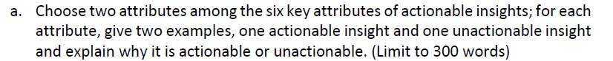

a. The 6 key attributes of an actionable insight are Alignment, Context, Relevance, Specificity, Novelty, and Clarity. But we are only talk about two attributes.

* Alignment: The potential that insights will become actionable insights is increased when they are aligned with the business objectives. Alignment not only makes things easier but also gives the insights a sense of urgency to spur action. As a result, the business goals also mean you are aware of the KPIs that correspond to them. Consequently, for your insights to be considered actionable, they must have an impact on certain KPIs and/or measures. Additionally, inspiring action can be triggered by clearly communicating insights and using the appropriate data visualisation. Clarity and organisation make the data stand out and become evident among the data noise. As a result, gathering data alone is insufficient. The value of the recommendations will increase as the data becomes completer and more correct. For example, if Airtel wants a customer per revenue, it can be treated as KPI indicator which can visualize through analysis. It provides actionable insights for per customer revenue.
* Relevance: The relevance attributes tell that to connect the knowledge to company strategic goals, it must be appropriate. It is difficult to thoroughly clean out actionable insights using data that is not in alignment using the company goals or policies. Similarly, to this, if the insights are really unactionable to use, then it's important to review the information collection process to make sure you're focusing on the essential aspects and variables. For example, if the customer data provides some meaningful insights such as customer satisfaction rise over the time period.



b) You aren't any longer only a customer or a price for Uber; instead, you are a gold mine of huge data that Uber uses for analytics. Uber is aware of all of your activities, including where you live, work, dine, travel, and when you do each of these things. Uber, a start-up in analytics, uses the vast amount of data gathered to provide personalised services and make enormous ROI by selling this data to its clientele. Uber addresses problems like poor transportation systems in some urban areas, poor customer service, late vehicles, poor satisfaction, drivers who won't accept credit cards, and that's just the tip of the iceberg.

They use the data in their success story, in order to determine the most neighbourhoods, utilises regression analysis to determine the size of the neighbourhood for example KNN algorithm. Uber uses the ratings it receives from its drivers and riders to analyse consumer satisfaction and loyalty. In simple words, the Behind-the-Scenes Process. Uber has a huge database of drivers, so as soon as you request a car, the algorithm gets to work and matches you with the nearest driver in under 15 seconds. Even when a driver has no passengers, Uber is saving data for every journey taken in the background.

**Section 2**

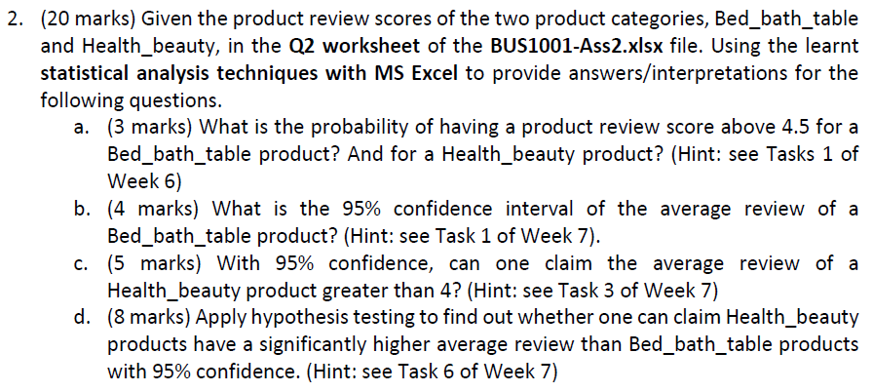

a. Probability Calculation:

* Bed_bath_table

|  |  |
| --- | --- |
| **Row Labels** | **Count of Bed_bath_table** |
| 1 | 36 |
| 2 | 19 |
| 3 | 35 |
| 4 | 69 |
| 5 | 191 |
| **Total** | **350** |

Probability (above 4.5 for Bed_bath_table) = 191/350 = 0.5457 = 54.57%.

* Health_beauty

|  |  |
| --- | --- |
| **Row Labels** | **Count of Health_beauty** |
| 1 | 40 |
| 2 | 5 |
| 3 | 28 |
| 4 | 62 |
| 5 | 220 |
| **Grand Total** | **355** |

Probability (above 4.5 for Health_beauty) = 220/355 = 0.6197 = 61.97%

b. **Confidence Interval = [3.888 – 4.169]**

Statistics Formula:

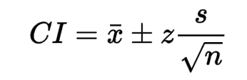

|  |  |  |
| --- | --- | --- |
| **Confidence Interval** | | **Formula** |
| Mean | 4.028571429 | =AVERAGE(A3:A352) |
| S.D. | 1.338983797 | =STDEVA(A3:A352) |
| n | 350 | =COUNT(A3:A352) |
| Confidence Coff. | 1.96 | =From Z table |
| Margin of Error | 0.14 | =(M8*M6)/(M7^0.5) |
| **Upper Bound** | **4.17** | =M5+M9 |
| **Lower Bound** | **3.89** | =M5-M9 |
| Max | 5 | =MAX(A3:A352) |
| Min | 1 | =MIN(A3:A352) |
| Range | 4 | =M12-M13 |
| C.I. |  |  |
|  |  |  |
| **C.I.** | **[3.89 – 4.17]** | |

c) **Confidence Interval = [4.29– 4.06]**

|  |  |  |
| --- | --- | --- |
| **Confidence Interval** | | **Formula** |
| Mean | 4.174647887 | =AVERAGE(B3:B357) |
| S.D. | 1.320387538 | =STDEVA(B3:B357) |
| n | 355 | =COUNT(B3:B357) |
| Confidence Coff. | 1.645 | =From Z table |
| Margin of Error | 0.12 | =(M23*M21)/(M22^0.5) |
| **Upper Bound** | **4.29** | =M20+M24 |
| **Lower Bound** | **4.06** | =M20-M24 |
| Max | 5 | =MAX(B3:B357) |
| Min | 1 | =MIN(B3:B357) |
| Range | 4 | =M27-M28 |
|  |  |  |
| **C.I.** | **[4.29 – 4.06]** | |

Null Hypothesis: The average review of a Health_beauty product less than 4.

Alternative Hypothesis: The average review of a Health_beauty product greater than 4.



Thus, the p-value of the test is 0.00 which is less than the level of significance. Based on the evidence, we can easily conclude that, reject the null hypothesis and in favor of an alternative hypothesis. Thus, The average review of a Health_beauty product greater than 4.